Lab-4

// 1: Write a program to create student class with data members rollno, marks1,mark2,mark3.
// Accept data (acceptInfo()) and display using display member function.
// Also display total,percentage and grade.

#include<iostream>
using namespace std;

class student{
private:
int rollno,marks1,marks2,marks3;

public:
void acceptInfo(){
cout<<"Enter rollno: ";
cin>>rollno;
cout<<"Enter marks1: ";
cin>>marks1;
cout<<"Enter marks2: ";
cin>>marks2;
cout<<"Enter marks3: ";
cin>>marks3;
}

int displayMember(){
cout<<"Rollno: "<<rollno<<endl;
cout<<"marks1: "<<marks1<<endl;
cout<<"marks2: "<<marks2<<endl;
cout<<"marks3: "<<marks3<<endl;

float total = marks1+marks2+marks3;
float perc = (total/300)*100;
cout<<"Total: "<<total<<endl;
cout<<endl;
cout<<"Percentage: "<<perc<<endl;
return 0;
}
};

// void Student :: acceptInfo(){
// cout<<"Enter rollno: ";
// cin>>rollno;
// cout<<"Enter marks1: ";
// cin>>marks1;
// cout<<"Enter marks2: ";
// cin>>marks2;
// cout<<"Enter marks3: ";
// cin>>marks3;

// }

int main(){
student stud;
stud.acceptInfo();
stud.displayMember();
}

Output:
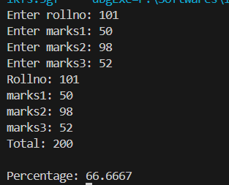

// 2.Create a class Person with data members as name, age, city. Write getters and setters for all the data
// members. Also add the display function. Create Default and Parameterized constructors. Create the
// object of this class in main method and invoke all the methods in that class.

#include<iostream>
using namespace std;

class person{
private:
string name;
int age;
string city;

public:
person(){
name = "abc";
age = 0;
city = "xyz";
}
person(string name, int age, string city){
this->name = name;
this->age = age;
this->city = city;

}
int display(){
cout<<"name: "<<name<<endl;
cout<<"age: "<<age<<endl;
cout<<"city: "<<city<<endl;
return 0;
}

// Getter
string getName(){
return name;
}
int getAge(){
return age;
}
string getCity(){
return city;
}

// setter

void setName(string newName){
this->name = newName;
}

void setAge(int newAge){
this->age = newAge;
}

void setCity(string newCity){
this->city = newCity;
}
};

int main(){
person obj_p;
obj_p.display();

person obj_p2("Akshat", 22, "Durg");
obj_p2.display();

obj_p.setName("Aryan");
obj_p.setAge(21);
obj_p.setCity("Bhilai");
obj_p.display();

return 0;
}

Output:
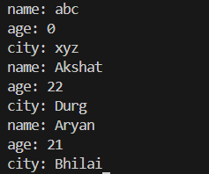

// 3.Create a class Date with data members as dd, mm, yy. Write getters and setters for all the data members. Also add the display function.
// Create Default and Parameterized constructors. Create the object of this class in main method and invoke all the methods in that class.

#include<iostream>
using namespace std;

class Date{
private:
int date,month,year;

public:
Date(){
date=1;
month=1;
year=2000;
}
Date(int date,int month, int year){
this->date = date;
this->month = month;
this->year = year;
}
int display(){
cout<<"Date: "<<date<<"/"<<month<<"/"<<year<<endl;
return 0;
}

//getter
int getDate(){
return date;
}
int getMonth(){
return month;
}
int getYear(){
return year;
}

//setter
void setDate(int newDate){
this->date = newDate;
}
void setMonth(int newMonth){
this->month = newMonth;
}
void setYear(int newYear){
this->year = newYear;
}

};

int main(){
Date obj_d;
cout<<"Default date"<<endl;
obj_d.display();
cout<<endl;

cout<<"parameterized date"<<endl;
Date obj_d1(19,6,2003);
obj_d1.display();

cout<<endl;

cout<<"Enter new date: ";
int newDate;
cin>>newDate;
cout<<"Enter new month: ";
int newMonth;
cin>>newMonth;
cout<<"Enter new year: ";
int newYear;
cin>>newYear;

obj_d1.setDate(newDate);
obj_d1.setMonth(newMonth);
obj_d1.setYear(newYear);

cout<<"update using setter"<<endl;

obj_d1.display();

return 0;
}

Output:
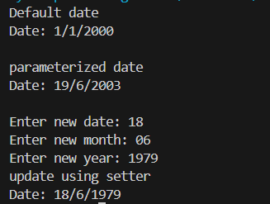

// Q4.Create a class Book with data members as bname,id,author,price. Write getters and setters for all the
// data members. Also add the display function. Create Default and Parameterized constructors. Create
// the object of this class in main method and invoke all the methods in that class.

#include <iostream>
using namespace std;

class Book{

private:
string bname;
int id;
string author;
double price;
public:
Book(){
bname = "default";
id = 0;
author = "default";
price = 0;
}

Book(string bname, int id, string author, double price){
this->bname = bname;
this->id = id;
this->author = author;
this->price = price;
}

void display(){
cout<<"\t\t--------------Book Details----------------"<<endl;
cout<<"book name = "<<bname<<endl;
cout<<"book id = "<<id<<endl;
cout<<"book author = "<<author<<endl;
cout<<"book price = "<<price<<endl;
}

//getter

string getbookName(){
return bname;
}
int getbookId(){
return id;
}
string getAuthorName(){
return author;
}
double getbookPrice(){
return price;
}

//setter

void setbookName(string newbookName){
this->bname = newbookName;
}
void setbookId(int newbookId){
this->id = newbookId;
}
void setAuthorName(string newAuthor){
this->author = newAuthor;
}
void setbookPrice(double newbookPrice){
this->price = newbookPrice;
}

};

int main(){

Book b1;
cout<<"\t\t---------------Default values--------------"<<endl;
b1.display();
cout<<endl;

cout<<"\t\t---------------Parameterized constructor--------------"<<endl;
Book b2("mera book",101,"Akshat",1000000);
b2.display();

cout<<"Enter new book name : ";
string newbookName;
cin>>newbookName;

cout<<"Enter new book Id : ";
int newbookId;
cin>>newbookId;

cout<<"Enter new author name : ";
string newAuthorName;
cin>>newAuthorName;

cout<<"Enter new book price : ";
double newbookPrice;
cin>>newbookPrice;

b2.setbookName(newbookName);
b2.setbookId(newbookId);
b2.setAuthorName(newAuthorName);
b2.setbookPrice(newbookPrice);
cout<<"\n\n\t\t------------updated details------------"<<endl;
b2.display();
}

Output:
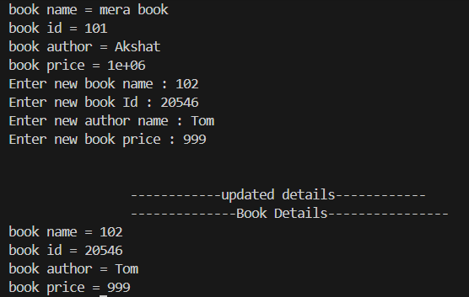

// 4. Create a class Point with data members as x,y. Create Default and Parameterized constructors. Write
// getters and setters for all the data members. Also add the display function. Create the object of this
// class in main method and invoke all the methods in that class.

#include<iostream>
using namespace std;

class Point{
private:
int x, y;
public:
Point(){
x = 0;
y = 0;
}

Point(int x, int y){
this->x = x;
this->y = y;
}

void display(){
cout<<"X = "<<x<<endl;
cout<<"Y = "<<y<<endl;
}

//getter

int get_x(int new_x){
return x;
}
int get_y(int new_y){
return y;
}

//setter

void set_x(int new_x){
this->x = new_x;
}
void set_y(int new_y){
this->y = new_y;
}

};

int main(){
Point pt;
cout<<"\t\t-------------default value----------"<<endl;
pt.display();

Point pt1(10,20);
cout<<"\t\t-------------Parameterized value----------"<<endl;
pt1.display();

cout<<"Enter new value of x = "<<endl;
int new_x;
cin>>new_x;

cout<<"Enter new value of y = "<<endl;
int new_y;
cin>>new_y;

pt1.set_x(new_x);
pt1.set_y(new_y);

cout<<"\n\t\t--------updated value-------------"<<endl;
pt1.display();

}

Output:

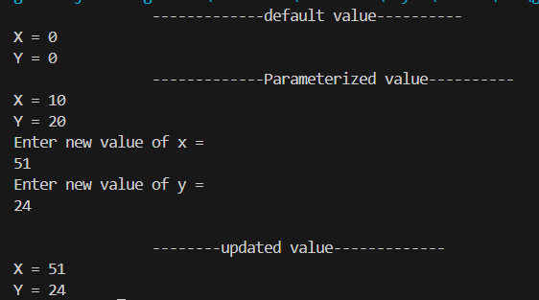

// 5. Create a class ComplexNumber with data members real, imaginary. Create Default and Parameterized constructors.
// Write getters and setters for all the data members. Also add the display function.
// Create the object of this class in main method and invoke all the methods in that class.

#include<iostream>
using namespace std;

class ComplexNumber{
private:
int real, imaginary;
public:
ComplexNumber(){
real = 0;
imaginary = 0;
}

ComplexNumber(int real, int imaginary){
this->real = real;
this->imaginary = imaginary;
}

void display(){
cout<<"Real:"<<real<<" Imagnery:"<<imaginary<<"i"<<endl;
}

ComplexNumber operator +(const ComplexNumber& obj){
int i1 = this->imaginary + obj.imaginary;
int r2 = this->real + obj.real;
ComplexNumber result(r2,i1);
return result;
}
// //getter

// int get_real(int new_real){
// return real;
// }
// int get_imaginary(int new_imaginary){
// return imaginary;
// }

// //setter

// void set_real(int new_real){
// this->real = new_real;
// }
// void set_imaginary(int new_imaginary){
// this->imaginary = new_imaginary;
// }

};

int main(){
ComplexNumber cn;
cout<<"\t\t-------------default value----------"<<endl;
cn.display();

ComplexNumber cn1(10,20);
cout<<"\t\t-------------Parameterized value----------"<<endl;
cn1.display();

// cout<<"Enter new value of real = "<<endl;
// int new_real;
// cin>>new_real;

// cout<<"Enter new value of imaginary = "<<endl;
// int new_imaginary;
// cin>>new_imaginary;

ComplexNumber complex1(10, 20);
ComplexNumber complex2(30, 80);

ComplexNumber complex3 = complex1 + complex2;
complex1.display();
complex2.display();
complex3.display();

// cn1.set_real(new_real);
// cn1.set_imaginary(new_imaginary);

// cout<<"\n\t\t--------updated value-------------"<<endl;
// cn1.display();

}

Output:
